**Task 4**

1. demonstarte: while , until loop any 2 sceanrio

**While Loop**: The loop is going to execute till condition is true.

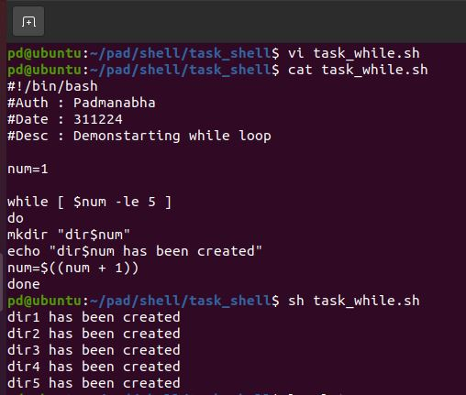

1. The loop creates directories named dir1, dir2, dir3, dir4, and dir5.
2. Each time a directory is created, a message is displayed indicating the directory was created.
3. The loop stops once num becomes greater than 5.

**Until Loop**: The loop is going to execute until condition becomes true

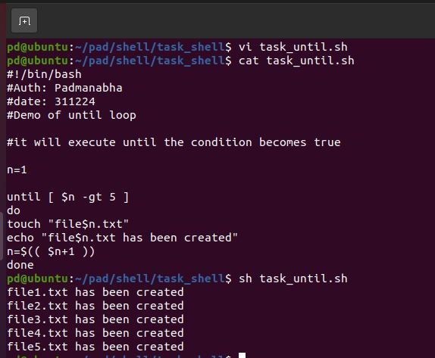

1. create 10 files
2. multiple of 3 text file , rest is log

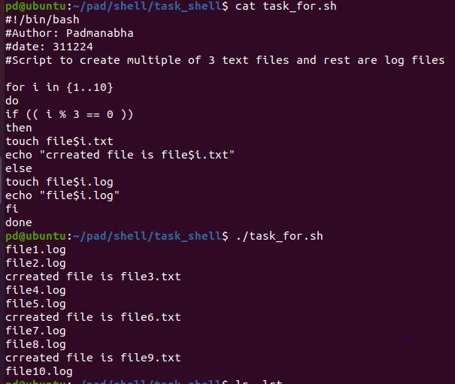

O/P

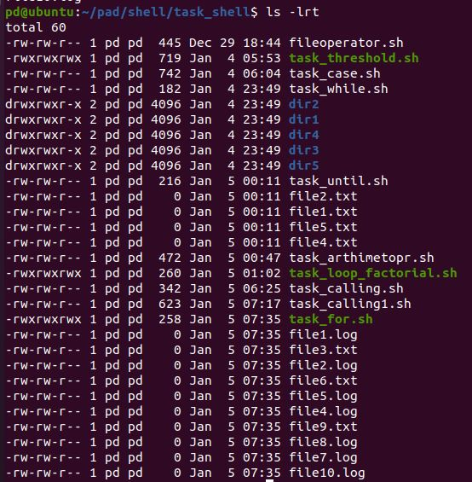

1. Use for loop (factorial)

